ACA ATHLETIC
HANDBOOK

THE KNIGHTS

Mission:
The Arkansas Christian Academy Athletic Department exists to support the school’s overall mission by providing a Christ-centered competitive athletic program that develops Christian character, leadership and a commitment to excellence. We recognize that God has gifted students in a variety of ways, including abilities in athletics. Our athletic programs provide an opportunity for these students to develop and use their God-given abilities.

Vision:
To continually strive for excellence in all aspects of athletics by committing to build eternal values by stressing attitude and team work and involve not only participants, but also the student body, staff, faculty, school family and the community in supporting the athletics programs.

Goals/Objectives:
- Glorify Jesus in all that is done on and off the playing field.
- Help the athletes establish a firmer and more personal relationship with Jesus Christ.
- Fully utilize the athletes God-given abilities.
- Improve the athletes’ overall physical condition and athletic skills.
- Provide a positive athletic experience for each athlete in order to encourage a lifelong enjoyment of sports and recreational activities.
- Building character: Handle conflicts, deal with success, and cope with disappointment.

Athletic Standard of Conduct:

Athletes, being role models for our elementary counterparts, must display a 24 –hour-a-day testimony that honors the Lord Jesus Christ. They are expected to show the same degree of respect and obedience to coaches as is expected of them in their relationship to classroom teachers. Athletes are required to uphold ACA policies and standards while following the rules set forth in the ACA handbook.
No student of any school, college, university, or other educational institution in Arkansas shall engage in what is commonly known and recognized as hazing or encourage, aid, or assist other students in the commission of this offense. The offense of hazing is a Class B misdemeanor.

Athletic Eligibility Guidelines:

Participation in competitive interscholastic activities as a part of Arkansas Christian Academy is a privilege and not a right. The eligibility rules are designed to promote the educational and spiritual values derived from participation in interscholastic activities. Student athletes at Arkansas Christian Academy should maintain the same academic standards required of all students in the school. Ultimately, the success in the classroom of students is determined through their willingness to accept responsibility for their efforts.

Coaches also have a responsibility in the process. They are to encourage players to seek academic excellence in the same manner they pursue excellence in athletics. During the course of the year, the grades for all student athletes will be monitored. If a student athlete’s grade falls below the passing mark, the student, teacher, parent and coach will develop an improvement plan to help the student make adequate progress in classes and show academic improvement. Also, the student athlete must have attended school two-thirds of the school day to participate in athletic practices and /or games. This rule applies to all sports offered at Arkansas Christian Academy.

Responsibilities of the Student Athlete:
- Must have a physical on file in the Athletic Director’s office prior to participation in a sport.
- Must have a signed parent consent form on file in the Athletic Director’s office prior to participation in a sport.
- Must adhere to the academic, disciplinary, and spiritual standards set forth by Arkansas Christian Academy to participate in athletics.
- Make a commitment to an athletic team and put your team’s successes above your individual successes.
- Show effort in practice and conditioning.
- Attend all practices and games unless otherwise discussed with the coach.
- Appear at the game site at least thirty minutes prior to game time unless otherwise instructed by the coach.
- Develop a respect for authority, including coaches, referees and parents and a respect for others including teammates and opponents.
- Accept the officials’ judgment at all times without complaint.
- No profanity, unsportsmanlike actions, will be tolerated.
Coaches’ Conduct:
Coaches will show respect toward officials, as well as the coaches and player of the opposing team. Coaches should make every effort to be the models of mature Christian behavior on and off the ACA campus. They will also be AED or CPR certified.
Coaches should be mindful of the physical safety of the students and not place the student in a position where serious injury may occur. Coaches must not physically or emotional abuse any student who is under his or her supervision. Coaches who fail to follow these guidelines will lose the opportunity of coaching at ACA.

Parents’ Conduct:
It is very important that parent function as role models for their children so therefore, parents are expected to respect coaches and school personnel as professional.
Parents are strongly encouraged to attend games in which their children are participating. Parental behavior at games should exemplify the behavior expected of the child/player. When a disagreement arises, the parents should talk to the coach involved at the appropriated time to resolve the matter. If the issue cannot be resolved, the matter will go through the chain of command: The Athletic Director and the Head Administrator, Pastor Perry Black.
We ask that parents not confront a coach after a contest. If a meeting with a coach is desired, this may be scheduled by calling the coach or Athletic Director. Parents are expected to refrain from negative comments about officials, coaches, and opponents. Parents who abuse the expectations of proper behavior may be asked to leave the premises and continued non-compliance will endanger the student’s eligibility of participate.

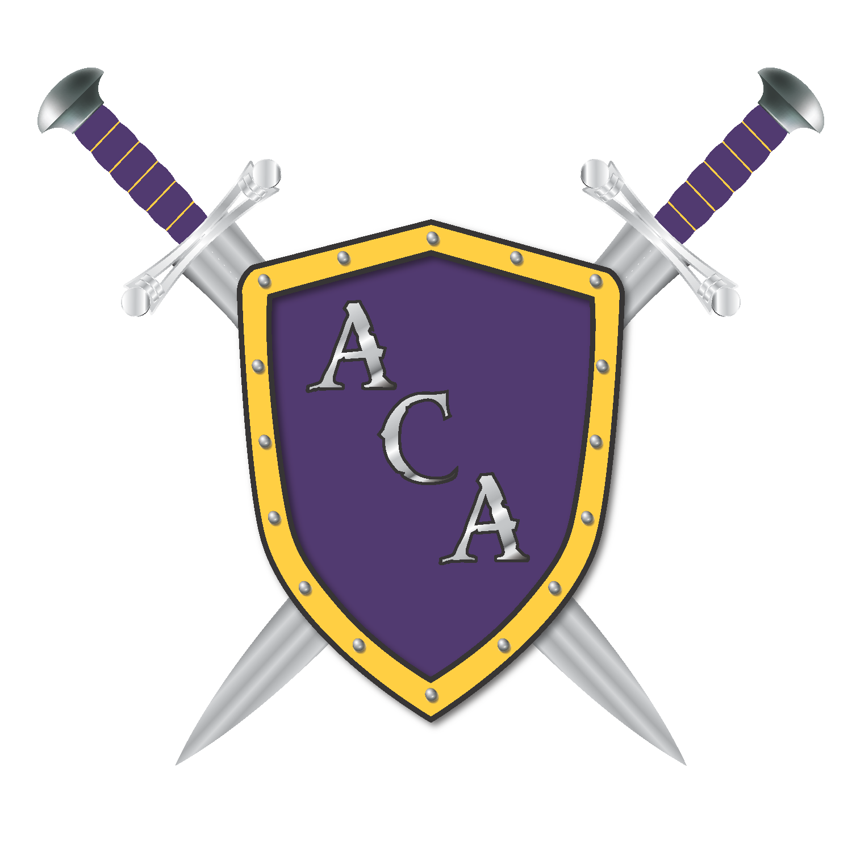 ACA Athletic
Handbook Addition

Student’s Name:_____________________________________________________Grade:_______________

I acknowledge that my student athlete must have attended school two-thirds of the school day to participate in athletic practices and/or games. This rule applies to all sports offered at Arkansas Christian Academy.

Parent/Guardian Signature:_________________________________________________________________

Date:_____________________________________________

This Form must be signed and returned to the coach before the above named student will be allowed to participate in any interscholastic sports.

ACA Athletic
Medical Consent Form

Student’s Name:_____________________________________________________Grade:_______________

I hereby grant permission for the coaching staff at Arkansas Christian Academy to administer over-the-counter medications to my student athlete during all athletic activities, which would include games, practices, etc. This rule applies to all sports offered at Arkansas Christian Academy.

Parent/Guardian Signature:_________________________________________________________________

Date:_____________________________________________

This Form must be signed and returned to the coach before the above named student will be allowed to participate in any interscholastic sports.

Cell Phone Policy:
Students’ cell phones and other communication devices, such as smart watches, are permitted to be taken on sporting activities and events. Such devices will be collected by the coaching staff at the designated bedtime during overnight trips. However, one student in each room will be allowed to keep their phone for emergency use. Any parent needing to reach their student after the designated time may do so by contacting the coaching staff directly.

